Create a Cloning of a VM and Test it by loading the Previous Version/Cloned VM using VMware workstation.
Aim: To clone a Virtual Machine using VMware Workstation and verify the cloned VM by running it and comparing it with the original VM configuration.
Procedure:
- Open VMware Workstation and select the existing Virtual Machine.
- Ensure the VM is powered off before cloning.
- Right-click the VM name in the Library panel.
- Select Manage ➜ Clone from the context menu.
- The Clone Wizard will open — click Next.
- Choose the current state of the VM or select a specific snapshot for cloning and click Next.
- Select cloning type:
- Full Clone – independent complete copy
- Linked Clone – depends on original VM's disk
Then click Next.
- Enter a name and location for the cloned VM and click Finish.
- After cloning completes, power on the cloned VM to test its functionality.
- Compare the configurations and operations of original and cloned VM to verify successful cloning.
Output:

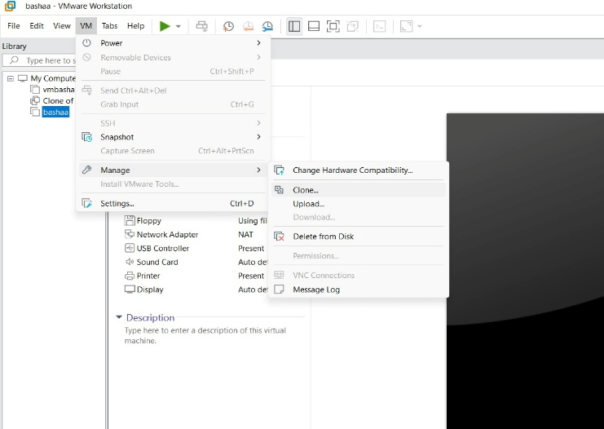
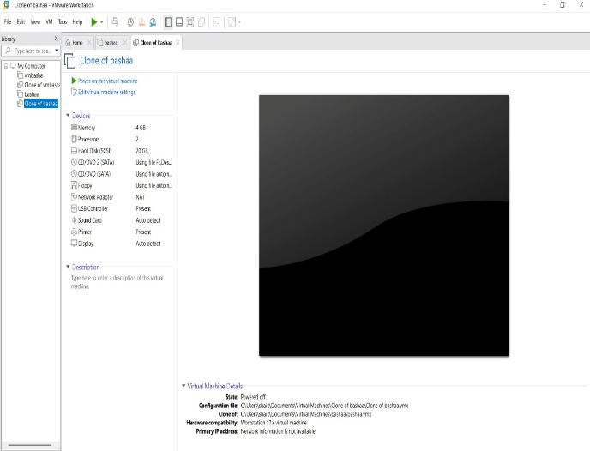

Result: A Virtual Machine was successfully cloned using VMware Workstation.
The cloned VM operated independently and restored the previous configuration, confirming that cloning helps in backup, testing, and duplication without affecting the original VM.

